Troy Order Planning System Proposal

# Overview

Troy schedulers currently follow a three-step process to plan release schedules to Honduras. The first and primary step involves the use of a spreadsheet called the “MPS Master.” In this spreadsheet they review customer demand, in-transit and on-hand inventory, current production orders, and various details, including purchasing lead-time, close-out dates, production shutdowns, and projected weeks on-hand. Part-by-part, the scheduler reviews this data and makes necessary adjustments to their releases to Honduras. These changes are aggregated across all of their parts and then dumped to an export file. In the second step, the scheduler imports the export file, thereby modifying their release schedules. In the final step, the current release schedule is written to Honduras’s sales schedule. Schedulers produce a new spreadsheet each week by repeating the process above and storing their spreadsheet on the “Everyone” drive in the appropriate folder. The department maintains this data for each week going back at least to 2009.

The “MPS Master” spreadsheet, though quite functional, leaves considerable opportunities for improvement, including:

* Loss of traceability – Important dates and computed fields in the MPS Master are inaccurate when opening archived versions of the file. Furthermore, researching a particular part’s history involves going through numerous old spreadsheets.
* Revision tracking – When issues occur in Honduras requiring a “recovery plan” to be coordinated, a plan may undergo a number of changes that are currently handled in an offline MPS spreadsheet and email.
* Complexity – The spreadsheet includes hundreds of computations, formatting rules, look-ups, etc., making it difficult to make revisions to the planning process or include other sources of information that could be used to improve visibility of various factors affecting production schedules.

**We are proposing a new on-line system to initially work alongside the current process and ultimately replace the current system, as well as serve as the platform for continuous improvement in scheduling.** The on-line system will store the scheduler’s planning data and historical data that drove that planning in a database. This will enable new reporting capabilities, various filtering, aggregation, and sorting method for research during resolution of issues including expedites, recovery plans, and customer charge-backs for release fluctuation. In addition, the on-line system will provide a solid basis for implementing new production-leveling rules, automation, and visibility tools, ultimately leading to a more reliable and efficient process for the scheduler. **However, the on-line system will work along-side the current process, in that any changes made in the new system will be reflected in the current process. This will enable a phased roll-out approach wherein** **schedulers can use the new system while verifying their plans in the current process or fall back to the current process if any problem is identified in the new system.**

# Structure

TOPS [Troy Order Planning System] will store “Planning Snapshot” records. A new snapshot will be created for every production part every week on Wednesday (or on demand). The Planning Snapshot will include and store a copy of current information including customer releases, on-hand and in-transit inventory, the current production release schedule, the longest lead time for components in days, the current SOP and EOP, standard pack, weekly production capacity, production holiday schedule, etc. The scheduler will make adjustments as needed to override the customer’s releases (as in the case when the customer’s release plan is insufficient for material planning) and to modify the production release plan to accommodate release fluctuations.

A Planning Snapshot will have a status field that indicates whether it is “OPEN”, “ACTIVE”, “CONFIRMED”, “REPLACED”, or “CANCELLED”. A new planning snapshot will be OPEN until it is either made ACTIVE in which case the modified production release plan will be written to Troy’s PO Detail and to Honduras’s Sales Order Detail. Activation of a new planning snapshot will automatically mark the prior ACTIVE or CONFIRMED planning snapshot as REPLACED, and any OPEN planning snapshots as CANCELLED. When Honduras reviews their new release plan from Troy, they make adjustments in accordance with their own requirements and capabilities and generate a confirmed production schedule. The confirmed production schedule will be recorded against the ACTIVE Planning Snapshot and its status will be changed to CONFIRMED.

Every Planning Snapshot will have an owner. Only the owner will be able to modify the Planning Snapshot, and only when it is an OPEN status. However, another user could make their own revision to an OPEN or ACTIVE release plan. If the scheduler in Troy needs to modify the ACTIVE or CONFIRMED Planning Snapshot, they will do so by creating a new revision of the ACTIVE snapshot; it will initially be OPEN.

# User-Interface

The system will provide a standard login screen. Various views will be made depending on the user’s role. The initial proposal is to provide a MPS Master Planning view and a MPS Traceability view.

## MPS Master Planning View

The primary view will be the MPS Master Planning view for a scheduler. The MPS Master view will present the scheduler with a list of all of their OPEN and ACTIVE Planning Snapshots. The list will provide summary information, including status, alerts (i.e. close-out notices, negative balances, excess inventory, etc.). The scheduler will select an OPEN Planning Snapshot to begin the process of reviewing the plan for that part. The view will display the Planning Snapshot Header and Planning Snapshot Grid.

### Planning Snapshot Header

The snapshot header displays summary information for the specific part. The following information is currently displayed:

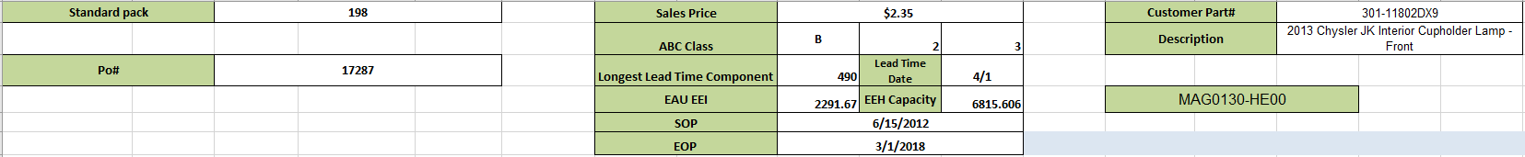

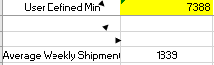 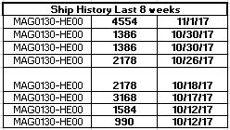

### Planning Snapshot Grid

The snapshot grid will enable the scheduler to review and modify the current production plan. The first section of the grid covers the current 14 days from Monday of this week through Sunday of the following week and will look like this:

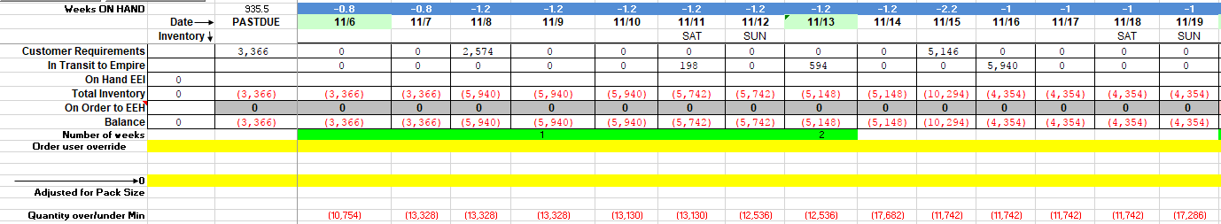

Beyond the current 14 days, the grid shows 56 weeks and in general looks like this:

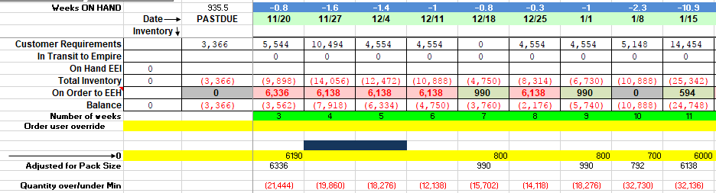

The snapshot grid will contain additional tags for special situations. In particular, for Closeouts, the weekly column headers will display 6-week countdown to the anticipated close out similar to this:

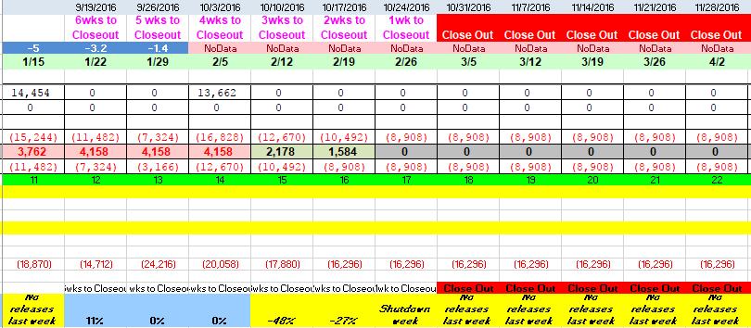

Also note that scheduled production shutdowns are indicated and prevent/limit planning:

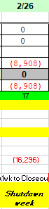

These tags will also be stored with the snapshot so that a historical view will show all of the information made available to the scheduler at the time of a planning decision.

## MPS Traceability View

The MPS Traceability view will present a full list of all of the planning snapshots, including those that have been cancelled or replaced. It will provide a scheduler or manager with comprehensive filtering tools to isolate a particular part (or base part) and time-range. The display of the details of any particular planning snapshot will be the same as that which is provided in the MPS Master Planning view, but these views will be read-only in this context.

# Development Deliverables and Estimated Costs

This proposal covers the initial deliverables, which primarily are focused on replication of the current process and its three components and providing an improved data structure and code-base for future improvements. However, it will be useful to break this down further into three separate phases.

## Phase 1:

In the first phase, the initial data-structure will be created and the initial version of the MPS Master Planning view will be created. The initial version of the MPS Master Planning view will include all of the procedural code for update the Troy purchase orders and Honduras sales orders, as well as updating the status of the planning snapshots. The Planning Snapshot Grid in this initial version will compute the “Weeks On Hand”, “Total Inventory”, and “Balance” rows of the Planning Snapshot Grid, but will implement a minimal amount of validation, color coding, tags, etc.

The goal of this phase is to provide a tool to begin testing while some of the more intricate details are worked on in phase 2. This initial phase will take 3 weeks and approximately $9,000 to complete.

## Phase 2:

The second phase will be focused on completion of the Planning Snapshot Grid, including all of the current business rules regarding holidays, close-outs, color-coding rules, etc. The final version of the Planning Snapshot Grid will be similar to the grid currently used in Excel, though the new version will be considerably more legible. Completion of the grid will take 2 weeks and approximately $6,000 to complete.

## Phase 3:

The final phase of this proposal will be the development of the MPS Traceability view. This view will be similar to the MPS Master Planning view but will provide additional sorting and filtering tools and will be read-only. It will take approximately 1 week and $3,000 to develop.

# Future Enhancements

TOPS will provide a foundation for future improvements to the scheduling process, including collaboration across teams, visibility of additional data from IHS [aka CSM or forecast] to raw component inventory, and automation or semi-automation of repetitive tasks and exception reporting.